SOLUTION ARCHITECTURE

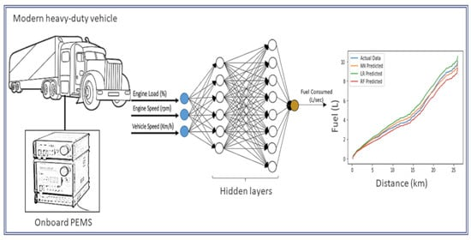

By,

S. Nandhini

V. Jayashree

K. Kalaiselvi

M. Sharmila